**Implement programs for estimating & eliminating trend in time series data- aggregation, smoothing.**

**EX.No:5**

**DATE:**

**AIM:**

To implement programs to estimate and eliminate trend in time series data using aggregation and smoothing methods.

**ALGORITHM:**

1. Start the program and import necessary libraries like pandas, numpy, and matplotlib.
2. Load the time series dataset.
3. Apply aggregation or smoothing techniques (like Moving Average) to estimate the trend.
4. Eliminate the trend by subtracting the estimated trend values from the original data.
5. Display the original data, trend (smoothed data), and de-trended data using plots.

**CODE:**

import pandas as pd

import matplotlib.pyplot as plt

from sklearn.metrics import mean_absolute_error, mean_squared_error

import numpy as np

df = pd.read_csv('Plant_1_Generation_Data.csv')

df['DATE_TIME'] = pd.to_datetime(df['DATE_TIME'], format='%d-%m-%Y %H:%M')

df.set_index('DATE_TIME', inplace=True)

df_daily = df[['AC_POWER']].resample('D').mean()

df_daily['MA_7'] = df_daily['AC_POWER'].rolling(window=7).mean()

df_daily['ES_0.8'] = df_daily['AC_POWER'].ewm(alpha=0.8, adjust=False).mean()

df_daily['Trend'] = df_daily['ES_0.8']

df_daily['Detrended'] = df_daily['AC_POWER'] - df_daily['Trend']

plt.figure(figsize=(14, 6))

plt.plot(df_daily.index, df_daily['AC_POWER'], label='Original', color='blue')

plt.plot(df_daily.index, df_daily['Trend'], label='Trend', color='red')

plt.plot(df_daily.index, df_daily['Detrended'], label='Detrended', color='green')

plt.legend()

plt.title('Trend Estimation & Detrending')

plt.xlabel('Date')

plt.ylabel('AC Power')

plt.grid()

plt.show()

mae = mean_absolute_error(df_daily['AC_POWER'], df_daily['Trend'])

rmse = np.sqrt(mean_squared_error(df_daily['AC_POWER'], df_daily['Trend']))

print(f"MAE: {mae:.2f}")

print(f"RMSE: {rmse:.2f}")

**OUTPUT:**

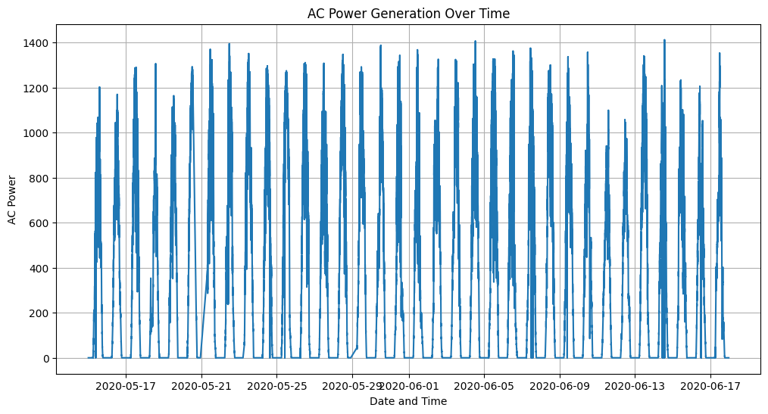

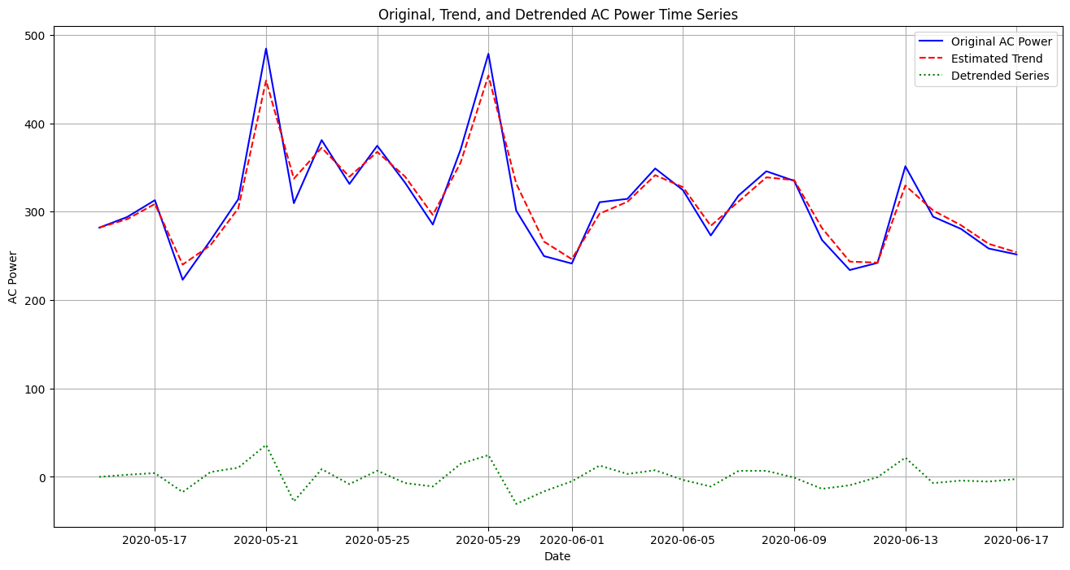

**RESULT:**

Thus the program has been completed and verified successfully.